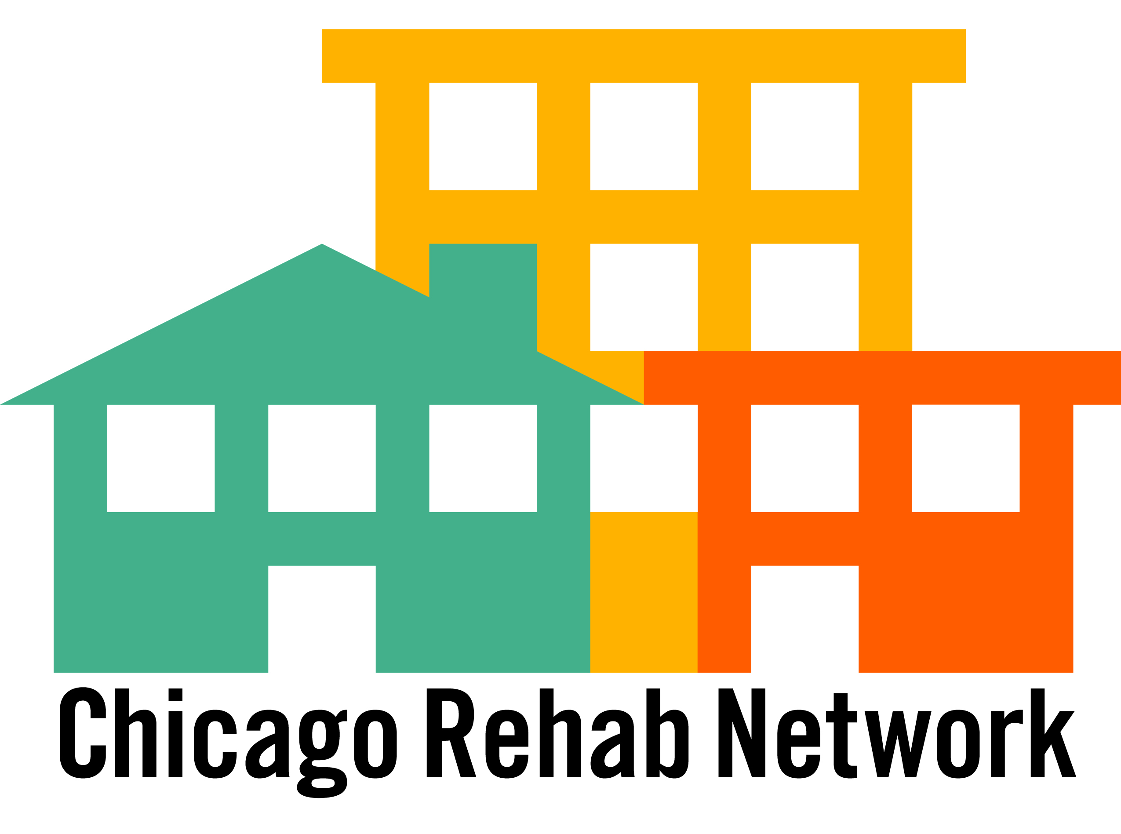

Lobbying 101
While some think that there is a mystique to lobbying, it really comes down to talking to your Member of Congress of staff person about an issue of concern to you. Every American has that right. As a housing advocate, you can, and should, lobby your congressional delegation. It is important to remember that you do now have to be an expert on housing policy to lobby. The experience and information you can provide on the housing situation in your Member’s district is very valuable to him or her. Indeed, you are the expert when it comes to what is going on in your district. And it is the responsibility of Members of Congress and their staff to be responsive to the concerns of their constituents.

Visitation with Member of Congress
If you have never met with a Member of Congress before, it may help to think of the visit as a 20-minute conversation that will give both your organization and your Member added insight into where each of you stands on a given topic.

Scheduling the Meeting
There are a couple of ways to schedule a meeting with a Congressional Representative. The best method is to fax a request in. Regular Mail delivery takes over two weeks to reach a Congressional office due to security standards. Thus- fax a request in. You can find your representative’s fax number on his/her website. Use the example letter attached to help request a meeting.

Although a face-face meeting with your Representative is often the most effective way to get your voice heard, given their busy schedules, they may not have time to meet with you. But, it is just as effective to meet with a staff member who deals with housing.
To get in touch with the housing staff person, you should call your Representative’s Office and ask who the Housing LA (Legislative Aide) is or who deals with housing- and what their email address is. Email is a much more efficient way of communicating with a staff member rather than calling them. Once again, you can use the letter form attached.

Planning the Meeting
Usually, a meeting will be no more than 20 minutes or half an hour long. Thus, you should map out your meeting.
- Decide what issues you’d like to discuss (usually no more than two or three), how to frame your message positively and simply, and what specific actions you would like your Member to take.
- Do Not Assume that your Members/ or Staff person understand/know of the problem. It is best to start with a description of the problem in your community, and then move on to solutions.

In deciding how to frame your message, it helps to know your Member’s professional interests and background. It also helps to know how your member voted on specific housing issues. You can review all roll call votes on key bills at http://thomas.loc.gov. If the Member’s record is favorable, remember to acknowledge his or her past support in the meeting. If a record is unfavorable you may express your concern, but remember that today’s opponent may be tomorrow’s ally.
*Gather written materials/handouts for the staff person- to remind them of your message.

